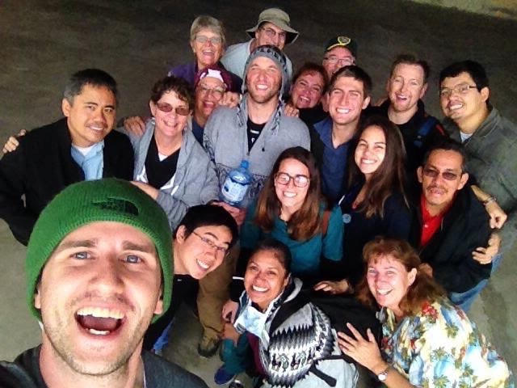
SAVE THE DATES

HRIMM NEWS
holy rosary international medical missions
www.hrimm.org

PERU
Medical work continues in Peru long after our 2016 mission has ended. Headed by Dr.s Renzo Mogollon and Armando Reyes, medical clinics are being conducted with the Las Hermanas del Perpetual Socorro hosting and an assembly of volunteers.
We are pleased for, and saddened by the loss of Dr. Mogollon as he has accepted a position in Boston developing clinical trials. Dr. Reyes will continue on for a few more months.

Philippines
HRIMM has begun fundraising for a clinic in Nueva Valencia, Guimaras. The Dominican Sisters have a plethora of resources and are able to acquire medical volunteers but don’t have a place to put them! We have committed to half the cost, $17,000. Blue prints have been drawn up.

Donations
Thank you to all our donors who make this work possible.
Speaking Tour: Mike Hayes has been on the fundraising speaking circuit, if your organization needs a speaker, contact him at mikehayes.hrimm@gmail.com

www.hrimm.org

April 29: When Two Worlds Collide; a documentary about the struggles between big oil and the indigenous people of the Amazon.
January 20-31, 2018; Medical Mission to Nueva Valencia, Philippines
June 15-28, 2018; Medical Mission to Peru.

Where Are They Now?
SR. VISITACION from our Philippine mission is in Rome for a month as part of the canonization process for their foundress, Mother Rosario. HRIMM board member MATT RILEY wrote her 150 page biography, a required step in this journey. KATHLEEN CUYUGAN is working hard at school (Nurse Practitioner) as are DAN RAFAEL (pharmacy) and STEPHEN YOON (dentistry). We wish you the best of luck! We welcome new HRIMM members, JJ RIVERA, born to CORAZON and EDGAR RIVERA and AIDEN CULBERSON, son to NANCY and ANDREW CULBERSON, congratulations to all of you! BRIAN CALLISTER has retired as national Medical Director of LifeCare Hospitals and is now teaching in addition to staff duties in Reno. ANNE HAYES will begin building her own home in Moab, UT, help is always welcome! Board Member MILLIE ESTRADA has been promoted to vice-principle of a local middle school, congrats!

